EXPERIMENT : 1

STAR TOPOLOGY

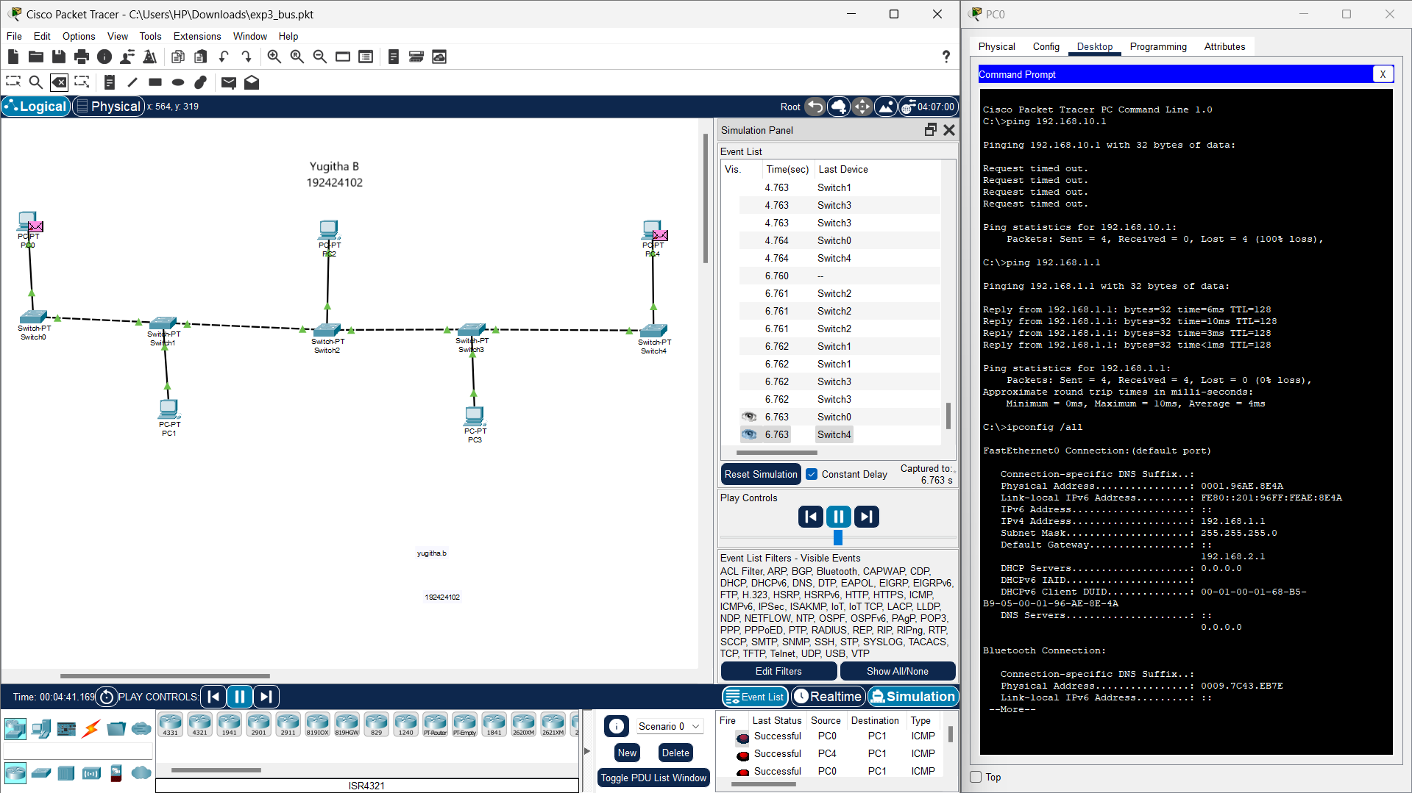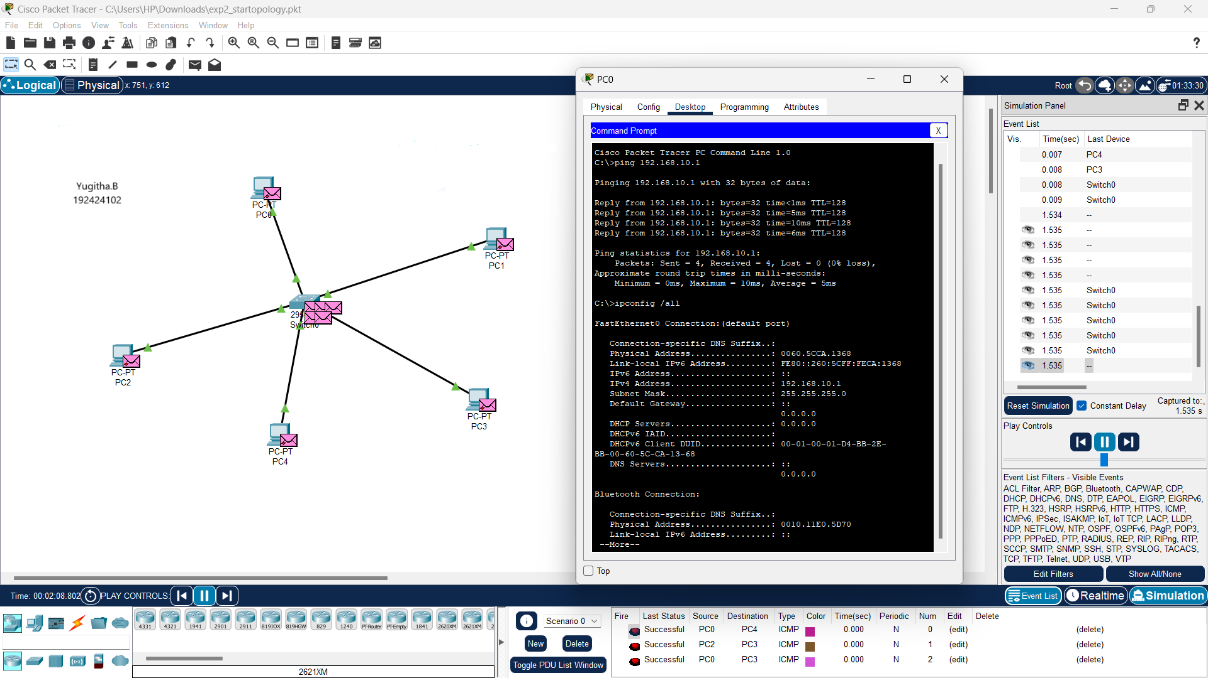

EXPERIMENT : 2

BUS TOPOLOGY

EXPERIMENT : 3

RING TOPOLOGY

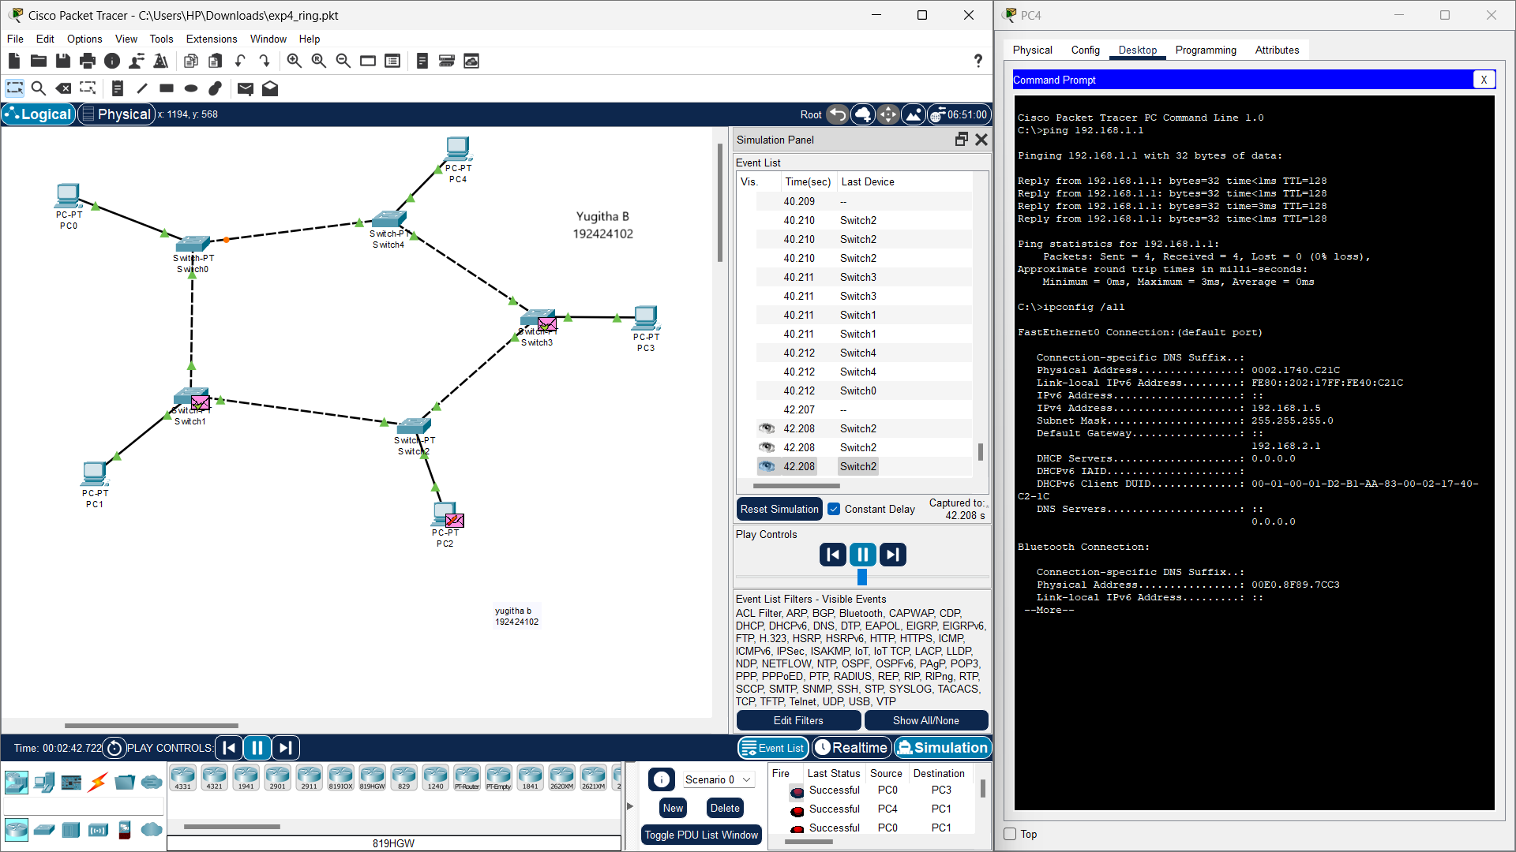

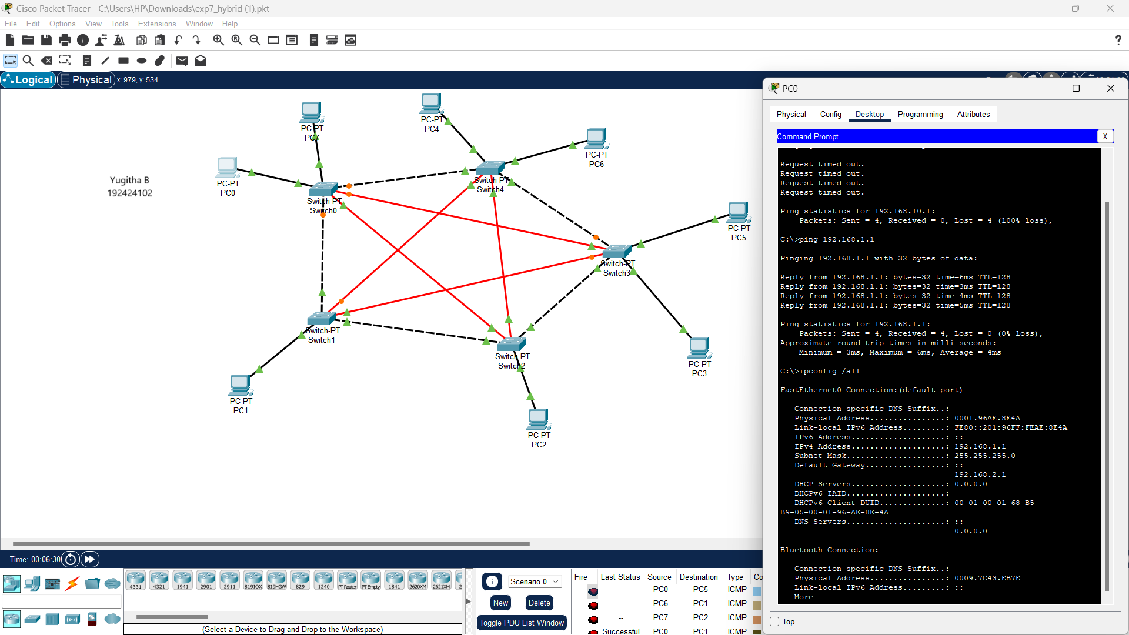

EXPERIMENT : 4

MESH TOPOLOGY

EXPERIMENT : 5

TREE TOPOLOGY

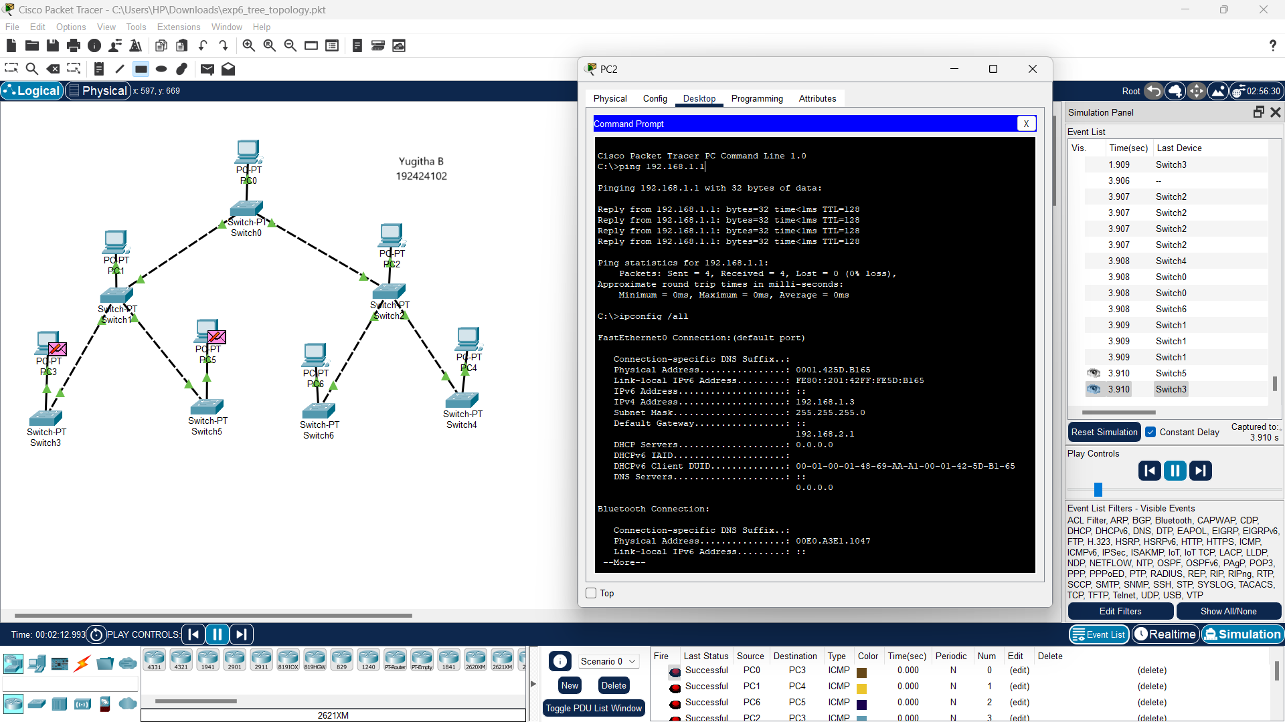

EXPERIMENT : 6

HYBRID TOPOLOGY

EXPERIMENT : 7

ARP

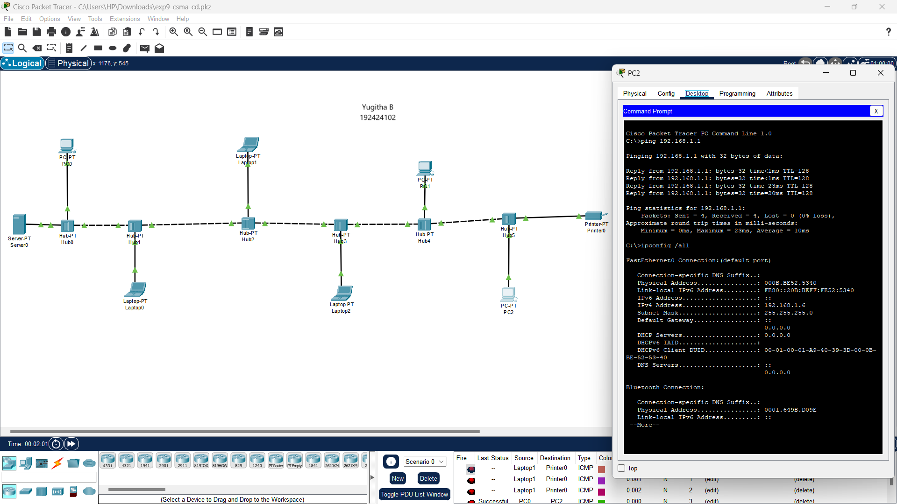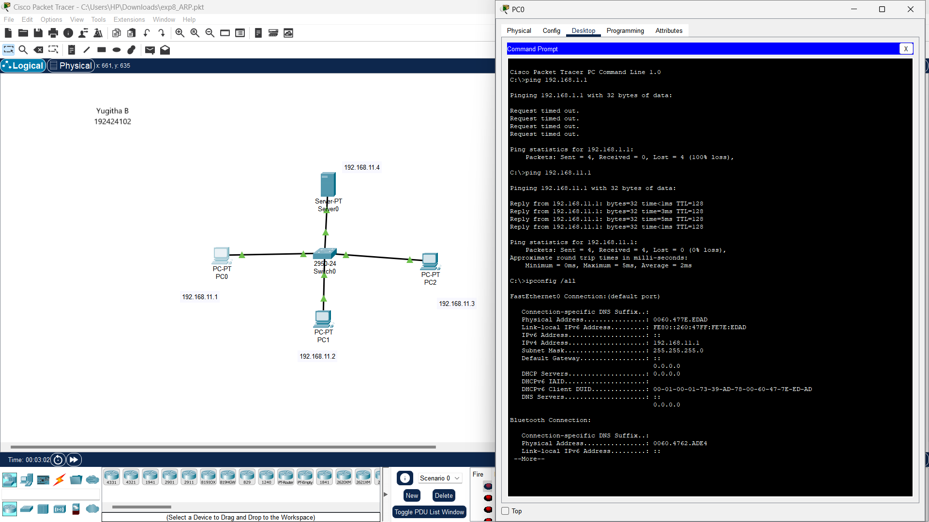

EXPERIMENT : 8

CSMA

EXPPERIMENT : 9

TCP

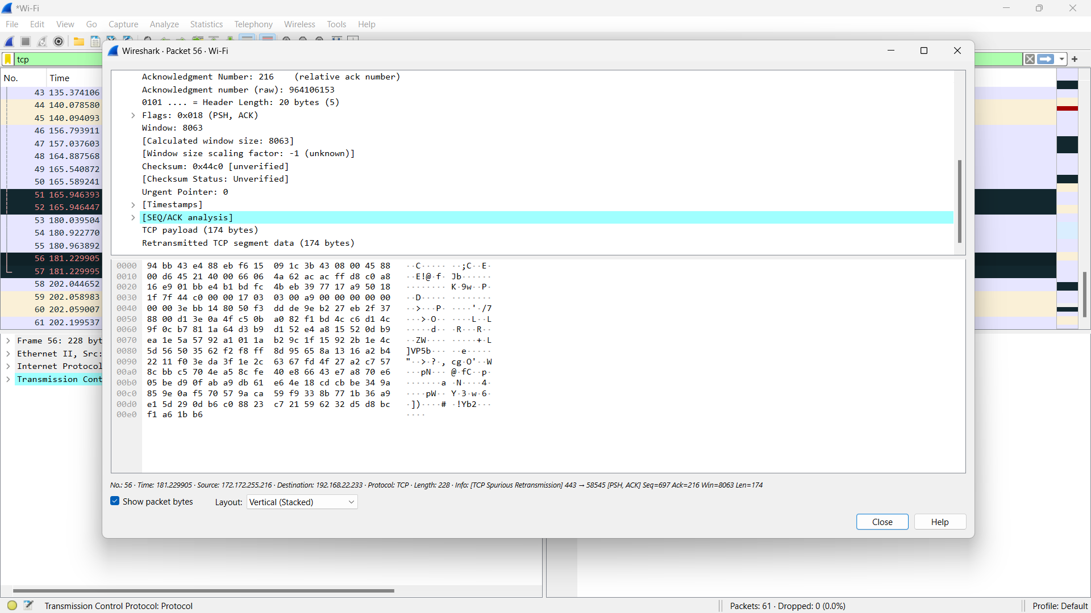

EXPERIMENT : 10

HTTP

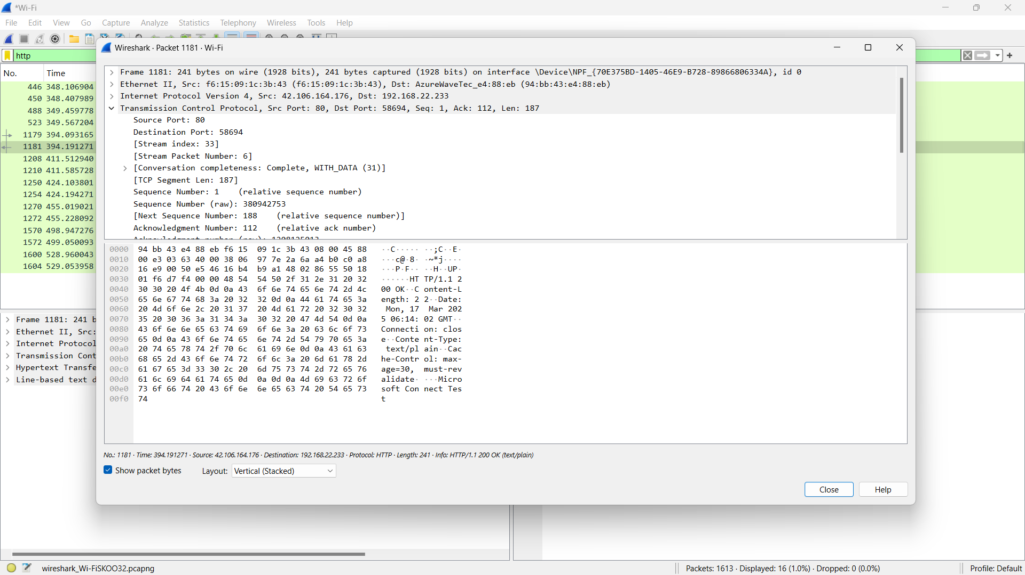

EXPERIMENT : 11

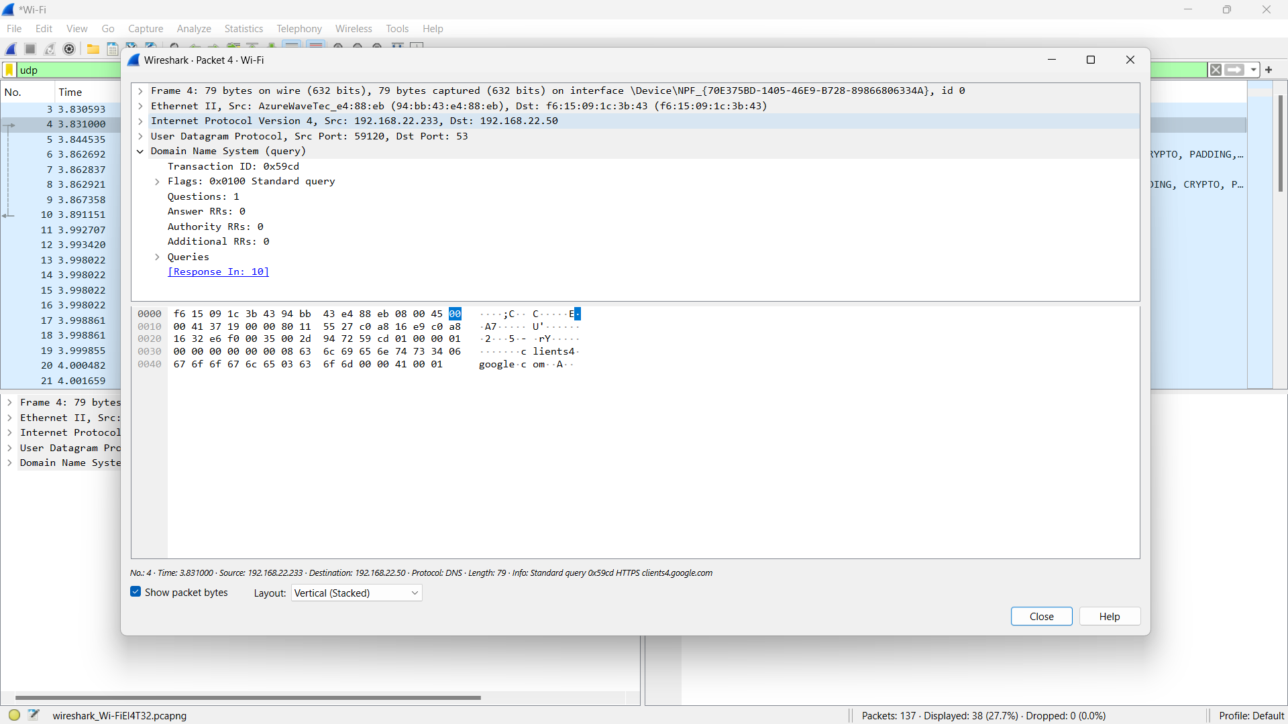UDP

EXPERIMENT : 12

ARP

